**Business Proposal: CampusTrail — All‑in‑One Campus Travel Hub**

**Prepared for: E‑commerce (Term IV), IIM Kashipur**Prepared by: CampusTrail Project Team  
Date: September 07, 2025  
Version: v3.3 (Full Report — Vertical Diagrams)

# Table of Contents

Note: Use Word’s References → Table of Contents to auto‑generate using the headings in this document.

# 1. Executive Summary

## 1.1 Introduction

CampusTrail is a campus‑only, multisided marketplace that unifies gear rentals, itinerary sharing, and travel companion matching within a verified student community. The platform embeds trust primitives—deposit lifecycle, verified identities, polymorphic reviews, QR/OTP handoffs, and simple disputes—so short‑haul, on‑campus exchanges are safe, fast, and affordable. The MVP is live; the roadmap advances payments, messaging, recommendations, reputation, media uploads, and Postgres migration.

## 1.2 Value Proposition

* All‑in‑one campus travel hub: one profile, one deposit wallet, one notification stream.
* Trust & safety by design: deposit hold → capture/release/refund, verified users, QR/OTP, evidence‑based disputes, and transparent reviews across people and assets.
* Faster, cheaper, greener: campus density lowers search and logistics cost; rentals encourage reuse.
* Connected journeys: itineraries reference required gear and find companions in‑context.

## 1.3 Product and Services

* Gear marketplace with buffer availability, rental lifecycle, deposits, and ratings.
* Itinerary planning with tags/interests, capacity, approvals; 0–100 match score to companion requests.
* Companion matching within a verified campus perimeter with safety cues and approvals.
* Polymorphic reviews across gear, itineraries, users, and companion requests.
* Orders & history snapshots for profile.
* Disputes with evidence and simple outcomes (release/capture/reject).
* Auth & security: OTP → JWT with rate‑limits; optional event logging.
* Planned: payment gateway (UPI/cards), messaging/notifications, uploads, recommendations, reputation score, locker hubs, Postgres + CI/CD, PWA polish.

## 1.4 Market Identification

Primary market: residential campuses with active club ecosystems. Secondary: alumni/near‑campus residents (KYC‑gated). Demand spikes pre‑fests and semester breaks; buying‑center spans society office bearers, lenders, and renters.

## 1.5 Sustainable Competitive Advantage

* Campus‑verified perimeter builds trust unavailable to city‑wide platforms.
* End‑to‑end integration (gear ↔ itinerary ↔ companions) collapses frictions competitors handle piecemeal.
* Embedded risk controls (deposits, QR/OTP chain‑of‑custody, disputes) reduce losses and moral hazard.
* Local liquidity shortens time‑to‑match; improves unit economics.
* Data flywheel: closed‑loop events improve recommendations and reputation scoring.

## 1.6 Marketing

* Positioning: “One app for gear, plans, and people—campus‑verified and deposit‑protected.”
* Channels: ambassadors, society tie‑ups, referral credits, UTM‑tracked social campaigns, micro‑events.
* Proof: deposit lifecycle demos, dispute flows, on‑time returns data.
* Metrics: request→paid %, time‑to‑first‑match, CAC via referrals, NSM = completed rentals/month.

## 1.7 Operational Plan

* Supply seeding: 100+ listings via clubs and incentives.
* Policy center: late fees, cancellations, returns inspections; evidence checklists.
* Service: in‑app tickets, SLAs (6h first response; 24h dispute triage).
* Tech ops: health checks, logging, error budgets, rollbacks; analytics funnels and cohorts.

# 2. Product/Service Information

## 2.1 Schematic Diagram

[Web/PWA (React+Vite, Tailwind)] → [Express+Zod API] → [Prisma ORM] → [SQLite (dev)/Postgres (prod)]; Optional: Payments (gateway), Storage (S3/Blob), Messaging/Notifications, MSSQL event log.

## 2.2 Use Cases (5 different)

* Fest DSLR Rental: deposit hold; QR/OTP pickup; inspection; deposit release; mutual reviews.
* Trekking Group Formation: itinerary host assembles group; shared gear cart; synchronized pickups; per‑item returns.
* Last‑Minute Tripod: proximity filter; instant approval; 30‑minute pickup; same‑day return; auto‑release.
* Club Gear Pool: verified club inventory; approvals queue; QR/OTP handoffs; utilization dashboard; ledger export.
* Damage Dispute Resolution: evidence upload; policy matrix; partial/full capture; reputation updates.

## 2.3 Activity Diagrams (Detailed per Use Case)

### 2.3.0 Generic Rental Flow

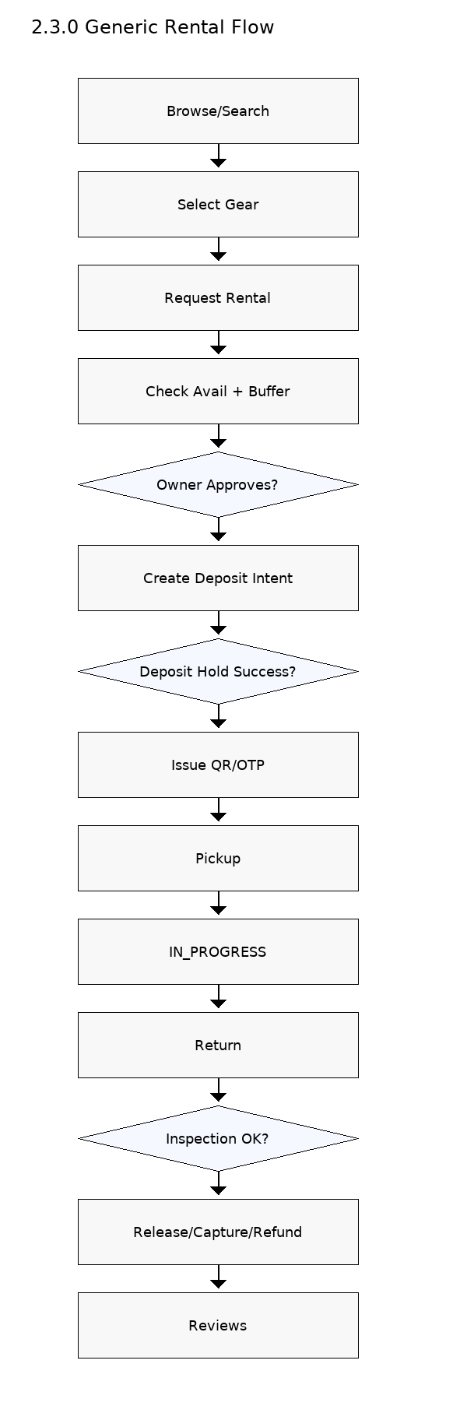

### 2.3.1 Fest DSLR Rental — Activity Diagram

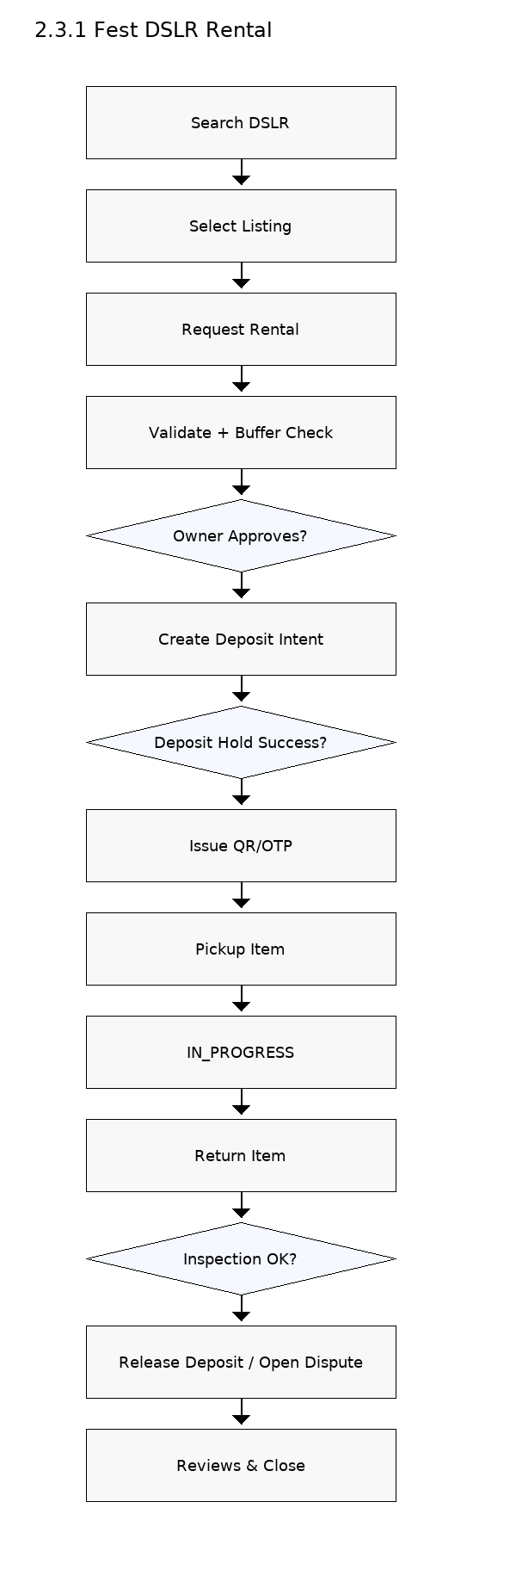

### 2.3.2 Trekking Group Formation — Activity Diagram

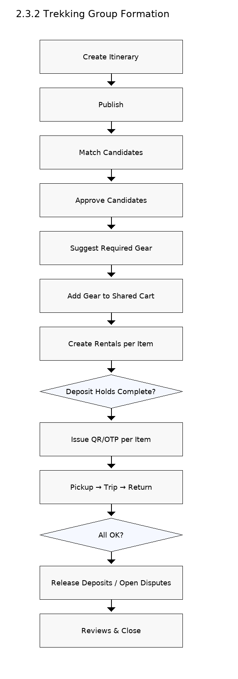

### 2.3.3 Last‑Minute Tripod — Activity Diagram

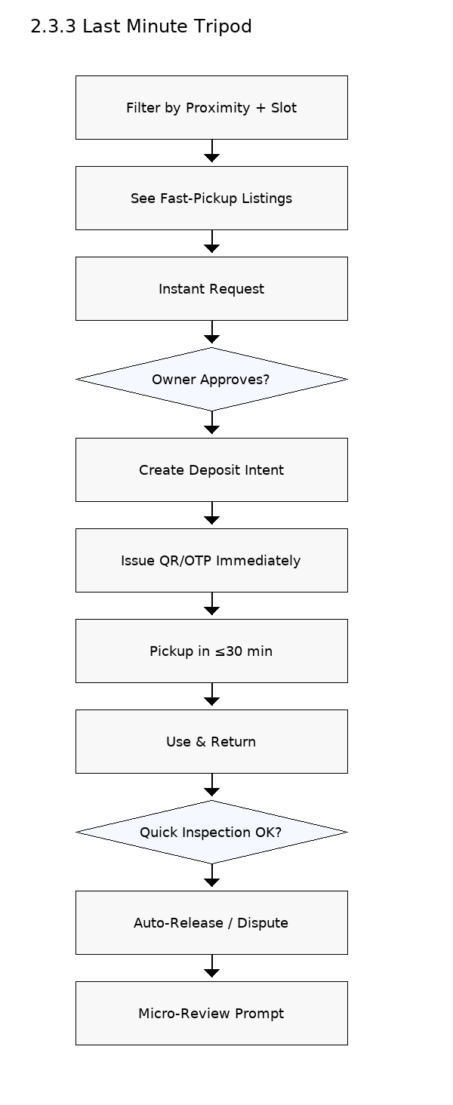

### 2.3.4 Club Gear Pool — Activity Diagram

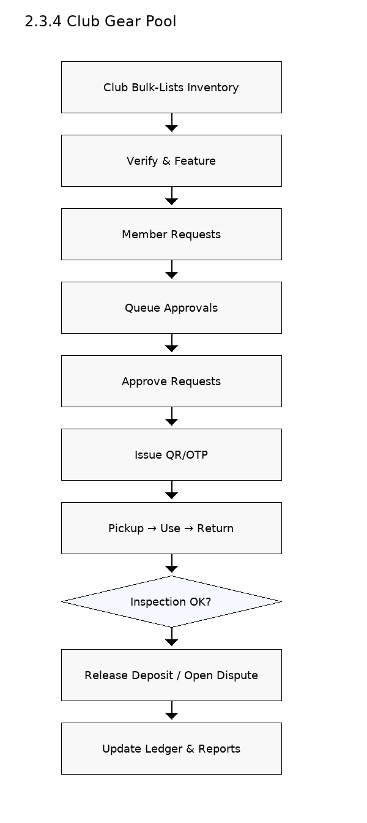

### 2.3.5 Damage Dispute Resolution — Activity Diagram

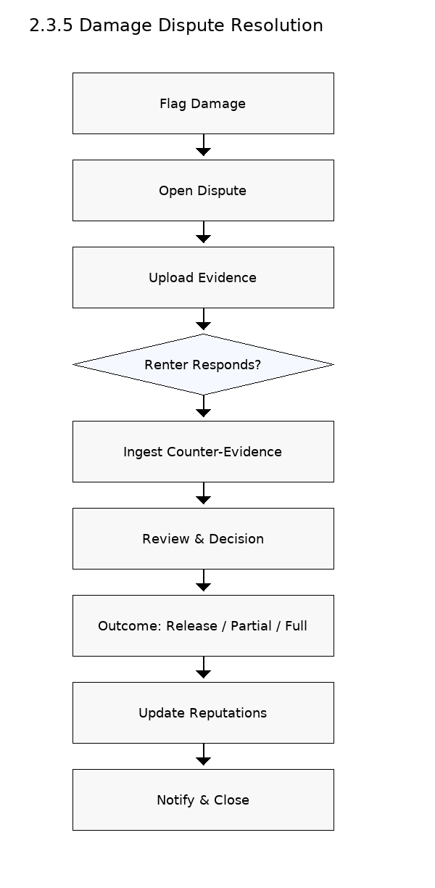

## 2.4 Sequence Diagrams (Key Interactions)

### 2.4.1 Deposit Hold/Capture/Release — Linear View

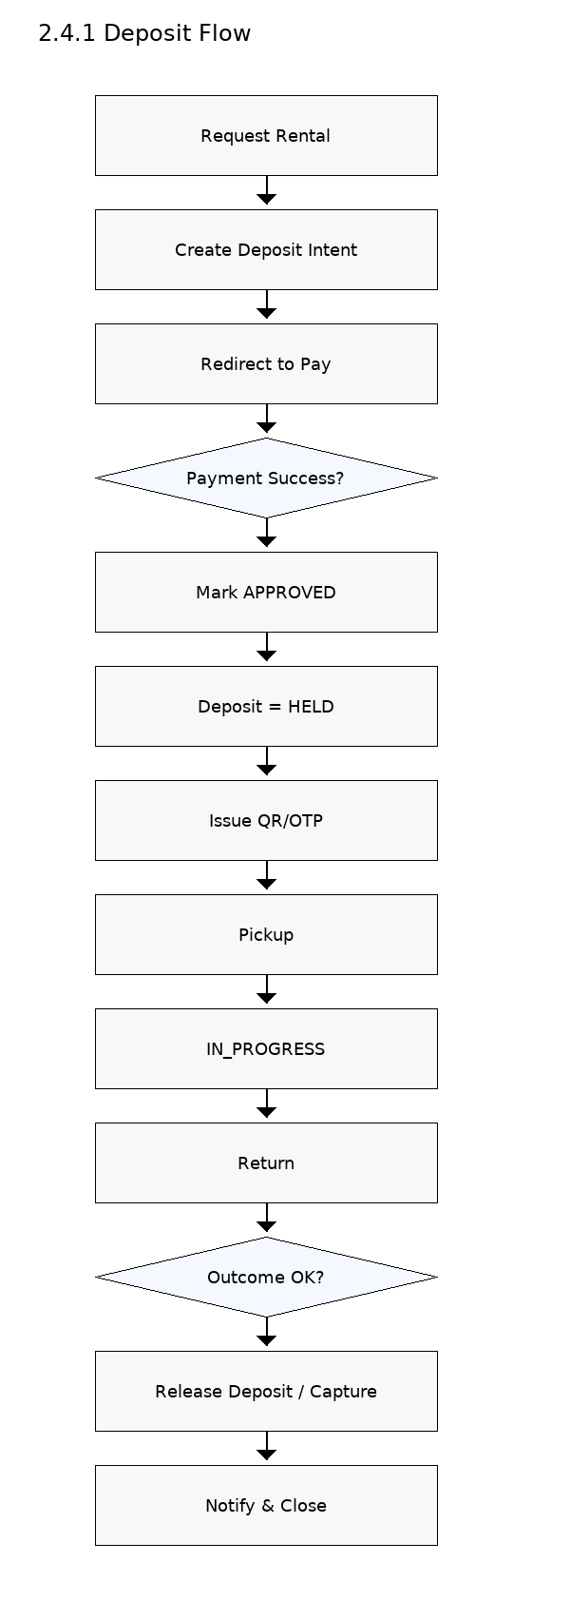

### 2.4.2 Dispute Resolution Flow — Linear View

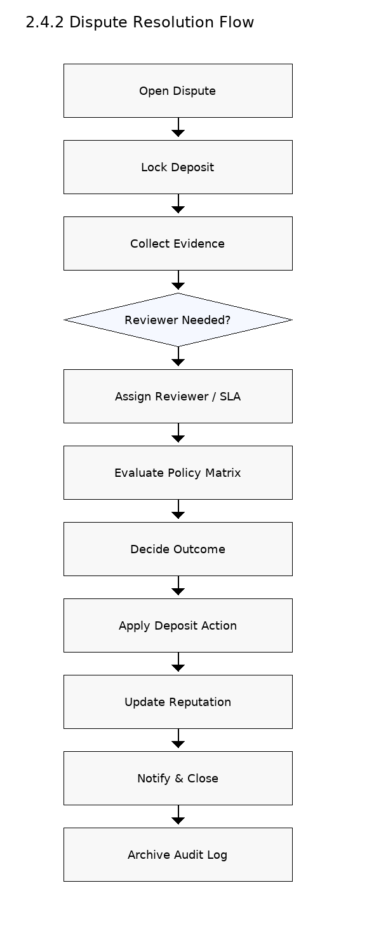

# 3. Industry Analysis and Market

## 3.1 Key Features of Conventional Services

* Meetup: groups/events discovery; no campus verification; no deposits or gear flows.
* Itinsy: itinerary creation/discovery; no transactional handoff or deposit logic.
* SharePal: city‑wide gear rental with item policies; not integrated with itineraries or companions; not campus‑verified.

## 3.2 Challenges Facing Conventional Services

* Fragmentation and drop‑offs across 2–3 tools; handoff failures.
* Trust deficits without .edu context; limited recourse for damage/no‑shows.
* Lack of escrow/deposits in planning flows (itinerary/companion).
* Long‑haul logistics vs short‑haul campus handoffs; misaligned SLAs.
* Siloed data; no closed loop from search → transaction → review.

## 3.3 Opportunities for Growth (CampusTrail)

* Unified journeys with embedded trust to improve conversion.
* Campus density for faster matches and better unit economics.
* Reputation and deposits unlock higher‑value items safely.
* Locker hubs + QR reduce friction and staff workload.
* Learning system: event data improves recommendations and policies.

# 4. CampusTrail

## 4.1 Customer Segments (Personas & JTBD)

* Riya (Renter, 21, Photography Club): find a DSLR today with fair deposit; trust the lender.
* Arjun (Lender, 23): list gear quickly; protect against damage; monetize safely.
* Meera (Club Admin): maintain inventory ledger; reduce losses; export monthly reports.
* Kabir (Itinerary Host): fill capacity with right people; ensure gear readiness; coordinate handoffs.
* Aisha (Companion Seeker): discover trips; vet participants; have safe backups.
* Campus Partner (Safety/Facilities): escalation visibility; locker access control; policy compliance.

## 4.2 Services Features Offered (Deep Dive)

Gear Marketplace: listings, rich metadata, photos; availability with buffer modes; rental lifecycle with QR/OTP; deposits with hold/capture/release/refund; late fees; cancellation windows.

Itinerary Planning: destinations/dates, capacity, styles; approvals; waitlist; match suggestions; link required gear; shared cart.

Companion Matching: safety cues (profile completeness, prior reviews, verified identity); host approvals; group chat (planned); roster; post‑trip feedback.

Trust & Reputation: polymorphic reviews; disputes with evidence, policy matrix, outcomes; audit logs and evidence bundles.

Orders & History: line‑item snapshots, receipts (email/PDF planned); club ledger exports.

Security & Auth: OTP→JWT; rate limits; device/session mgmt and anomaly detection (planned).

## 4.3 Future Growth Potential (Scenarios & Moats)

* Transacting at scale: gateway for UPI/cards; automated receipts; partial capture; risk scoring.
* Engagement: in‑app messaging; notifications; review nudges; badges (On‑Time Pro, Trusted Lender).
* Intelligence: recommendations; reputation score blending reviews, disputes, on‑time metrics.
* Operations: locker hubs; QR kiosks; dashboards; SLA analytics; incident heatmaps.
* Ecosystem: insurance add‑ons; affiliate gear feeds with campus verification.
* Expansion: Postgres/CI/CD; multi‑campus rollout with localization; campus #2–#5 playbook.

## 4.4 Key Market Drivers (with Implications)

* UPI ubiquity & QR literacy → prioritize UPI and QR UX.
* Sustainability & budget sensitivity → emphasize reuse and TCO reduction.
* Club culture & peer networks → ambassador program, society tie‑ins.
* Safety expectations → invest in moderation and evidence tooling.

# 5. PESTEL Analysis

* Political: campus MOUs; grievance processes; state consumer norms.
* Economic: student budgets; seasonal demand; gateway MDR; price elasticity.
* Sociocultural: peer influence; club activities; sustainability; safety norms.
* Technological: UPI/NFC/QR; PWA; cloud; analytics; AI recommendations.
* Environmental: rentals reduce waste; repair/reuse policies.
* Legal: terms of use; privacy/data retention; GST on commissions; IP for images.

# 6. Porter’s Five Forces Analysis

* Threat of New Entrants: moderate—tech is buildable; campus trust/liquidity and policies are moat‑like.
* Supplier Power (Lenders/Clubs): medium—multi‑homing possible; reputation and convenience add stickiness.
* Buyer Power (Renters/Hosts): medium‑high—price sensitive; offset by convenience and safety.
* Threat of Substitutes: high—buying gear, generic groups; mitigated by integrated flows and escrow.
* Industry Rivalry: fragmented—no campus‑focused full stack rival; city‑wide players compete on single legs.

# 7. Value Net Model

* Customers: renters, itinerary hosts, companion seekers.
* Suppliers: lenders (students/clubs), itinerary/content creators, payments/storage vendors.
* Competitors: Meetup, Itinsy, SharePal; spreadsheets/WhatsApp as baseline.
* Complementors: lockers, insurance partners, safety cells, maps/analytics.
* Co‑opetition: affiliate supply syndication while retaining campus verification and deposit logic.

# 8. Operations Plan

## 8.1 R&D Department (Website)

* Stack: React 18 + Vite, Tailwind, Express/TypeScript, Prisma; SQLite→Postgres.
* Practices: trunk‑based, code reviews, feature flags, strict TypeScript, Zod validation, security linters.
* Quality gates: tsc/noEmit, unit tests (Vitest/Jest), schema checks, endpoint smoke tests, CI (GitHub Actions).
* Backlog: payments, dispute UI, Orders UI, uploads, messaging, recommendations, reputation, error envelope/pagination, analytics, PWA.

## 8.2 Sales & Marketing

* Seeding: 10–15 ambassadors; club MoUs; featured lister badges; fee holidays.
* Campaigns: referral credits; UTM reels; on‑ground demos; bulk listing drives.
* Measurement: requests; approvals; request→paid %; time‑to‑match; GMV; take‑rate; CAC; K‑factor; retention.
* Content & Safety: how‑tos; policy explainers; safety checklists.

## 8.3 Finance

* Pricing: 8–12% take‑rate on rental fee (no fee on deposit).
* Illustrative unit economics: Revenue = GMV × take‑rate; Gross Margin ≈ Revenue − (gateway + support + hosting).
* Controls: monthly GMV close; dispute provisions; audit logs; dashboards for GMV, revenue, MDR, dispute costs.
* Future monetization: featured slots; locker access; insurance add‑ons; dashboards.

## 8.4 Customer Service

* Channels: in‑app tickets + email; status updates; macros.
* SLAs: first response ≤6h; dispute triage ≤24h; resolution ≤72h with complete evidence.
* Playbooks: late/no‑show; damage tiers; abuse/ban; privacy requests.
* Voice of customer: NPS; tagged root causes; feedback into backlog.

## 8.5 Logistics & Procurement

* Handoffs: QR/OTP codes; slotting windows; buffer education.
* Locker pilot: RFP with facilities; access control; audit logs; insurance riders.
* Procurement: signage; QR stands; protective cases; repair kits.

# 9. Timeline from Start to Launch and Next 1 Year (−12 to +12 Months)

## Pre‑Launch Plan (T−12 to T−1)

* T−12 to T−9 (Discovery & Foundations): interviews (≥40), benchmarking, deposit/dispute policies, MOU draft, data model v0, prototypes; gate: validated need.
* T−8 to T−6 (MVP Build): Express/Prisma core, OTP→JWT, listings & availability, rental lifecycle skeleton, reviews v0; seed 30+ listings; gate: happy path in dev.
* T−5 to T−3 (Alpha): buffer logic, dispute scaffold, orders snapshot, event logging; 20–30 users; gate: mock request→paid ≥20%, on‑time returns ≥90%.
* T−2 (Beta Hardening): itinerary/companion flows, match scoring, policy center; 60–100 users; gate: NPS ≥30, ≤3 critical bugs.
* T−1 (Go/No‑Go): incident runbooks, SLAs, macros, analytics dashboards, content kit; freeze D−3; gate: readiness 100%.

## Launch & Year‑1 Plan (T0 to T+12)

* T0–T+1 (Stabilize): go‑live; daily standups; fix P0/P1s; Orders UI; funnels; PWA polish.
* T+2–T+3 (Transact): payment gateway live (hold/capture/release), receipts; risk monitoring; review prompts; gate: deposit success ≥95%.
* T+4–T+6 (Engage): messaging/notifications; recommendations v1; reputation v1; club dashboards; gate: repeat renter ≥30%.
* T+7–T+9 (Scale Ops): locker pilot; Postgres cut‑over; CI/CD with e2e smoke; growth experiments (referrals, deposit sizing).
* T+10–T+12 (Expand): campus #2 rollout; localization; insurance partner PoC; de‑risking playbook.

## Milestone KPIs

* T−1: 60+ listings; 3+ clubs onboarded; knowledge base live.
* T+3: GMV ₹1–1.5L/mo; request→paid ≥25%; dispute rate ≤2%.
* T+6: GMV ₹2–3L/mo; repeat renter ≥35%; on‑time returns ≥95%.
* T+12: 2 campuses; GMV ₹5L+/mo; NPS ≥45; net dispute loss <0.7% GMV.

# 10. Conclusion

CampusTrail offers a single, campus‑verified platform for gear rentals, itinerary sharing, and companion matching—closing a key fragmentation gap. By embedding deposit lifecycle, QR/OTP handoffs, disputes, and polymorphic reviews into the core flows, the platform reduces risk and friction while improving affordability and sustainability. With payments, messaging, recommendations, and locker‑based operations on the roadmap, CampusTrail is positioned to become the default student travel hub on campus and beyond.